**SMART AGRICULTURE**

**REPORT:**

In India, agriculture plays a major role in developing the country. So our main moto is to make the farmer easy to monitor the farm.

From this project the farmer is able to monitor the values like soil moisture level, air quality in the field, humidity content and the temperature present in the farm. Through this project we can help the farmer to automatically on or off the motor based on soil moisture level.

Components required are soil moisture sensor(YL-69/HL16),temperature sensor(LM35), Air qualifier sensor(MQ-135), humidity sensor(DHT-11), DC motor, ESP32, Arduino IDE software.

All the sensors mentioned are interfaced with the ESP32.

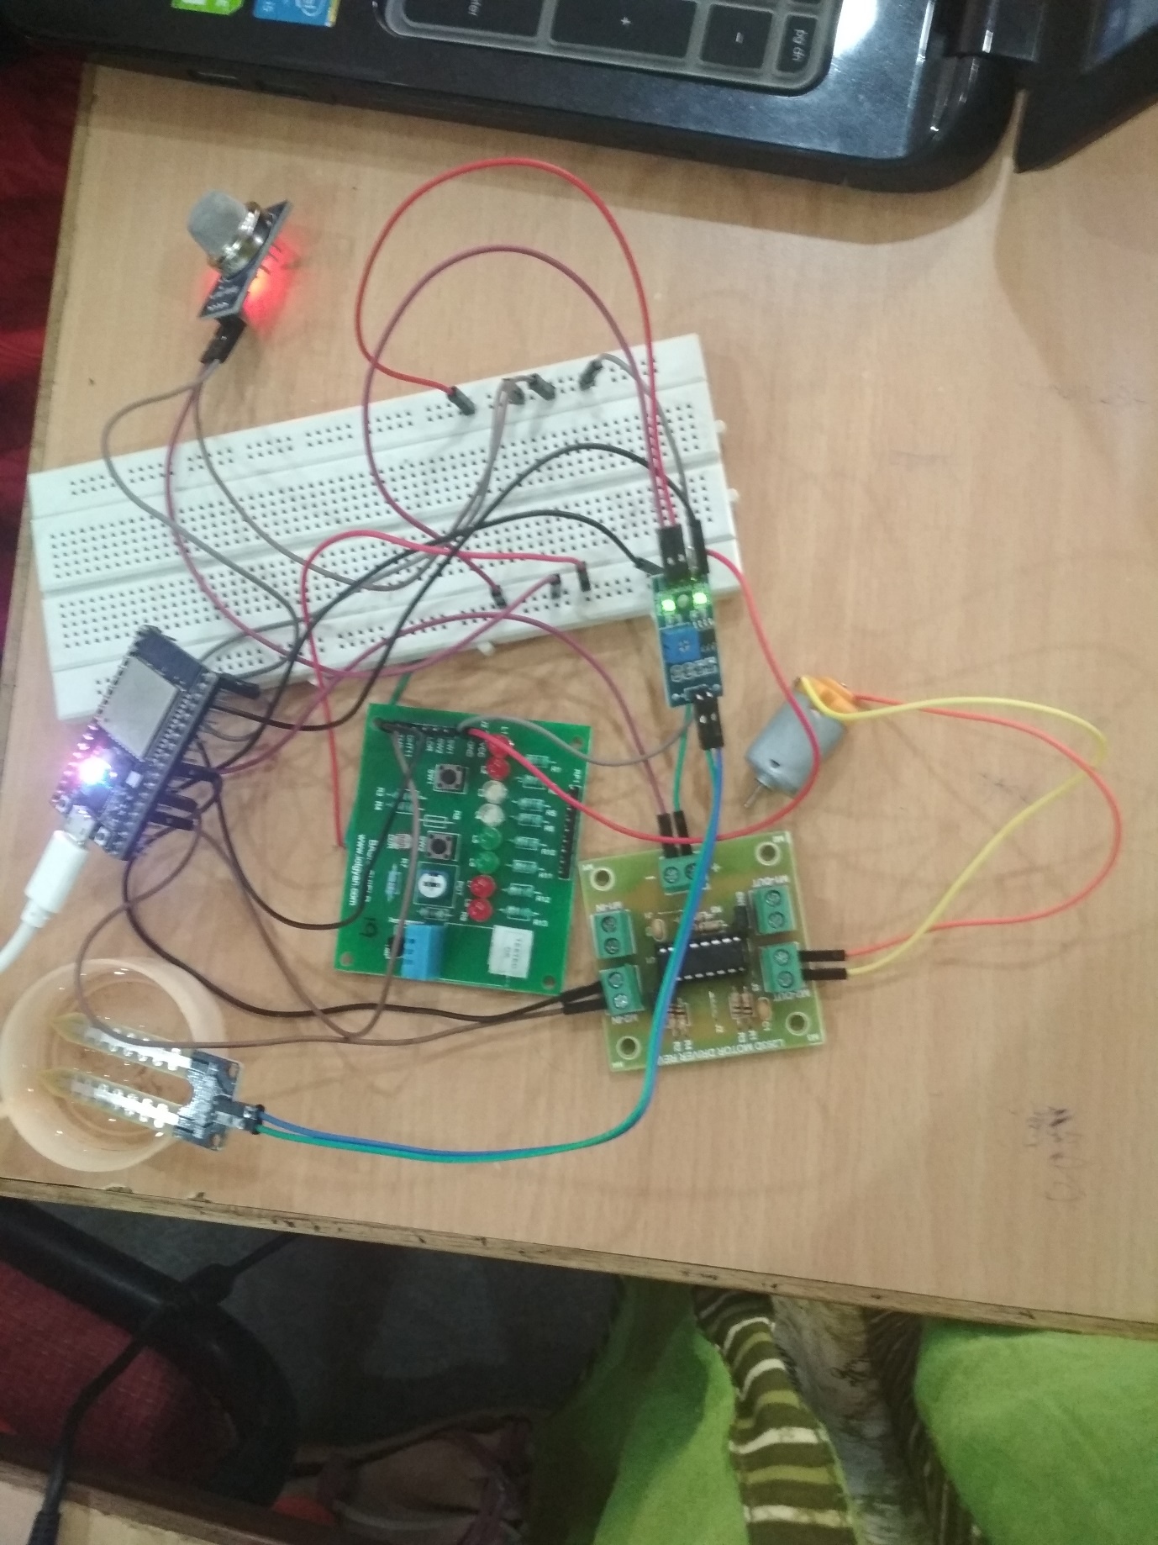

Coding for the project has been done in the Arduino IDE. The values can be monitored in the serial monitor, Web page, ThingSpeak.

By connecting to the WIFI access we can monitor the values with the help of IPaddress.

The web page monitoring is as shown :

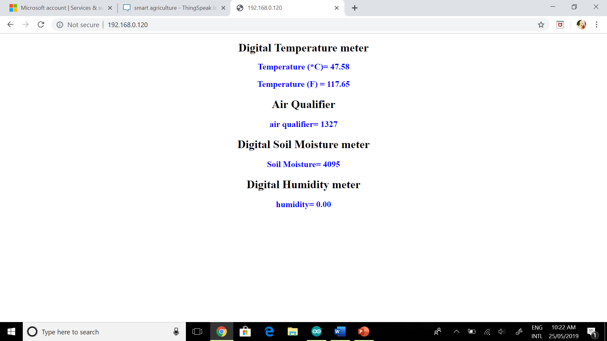

The ThingSpeak monitoring is as shown below:

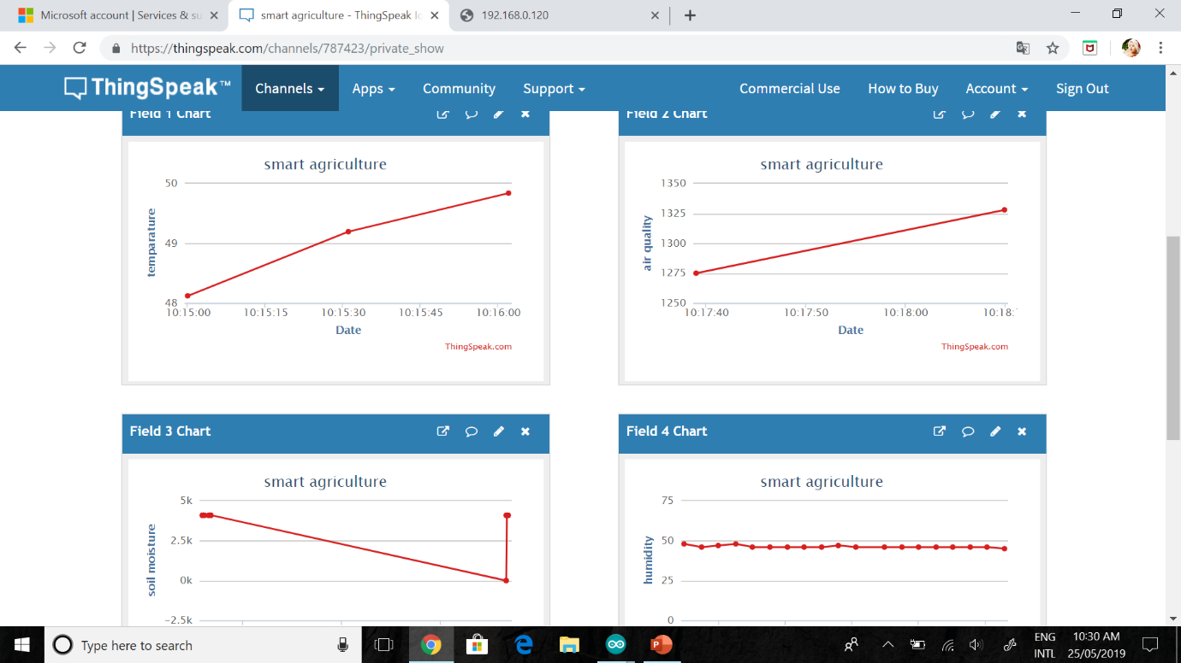

The values are updated for every 15 seconds.

Whenever the soil moisture value is beyond the threshold value then the motor automatically gets on and field is watered.

FUTURE EXTENSION:

This project can be extended by using GSM module that the farmer can get the access and alert messages.

BY,

K. Baby Priyanka

K. Venkata Deepthi

M. Kaileswari